**Jmeter - Pre-Processors**

Anything one wants to execute before or after a sampler can be done using a pre or post processors.

Create a Thread Group -> Add -> Pre Processors -> Use Parameters

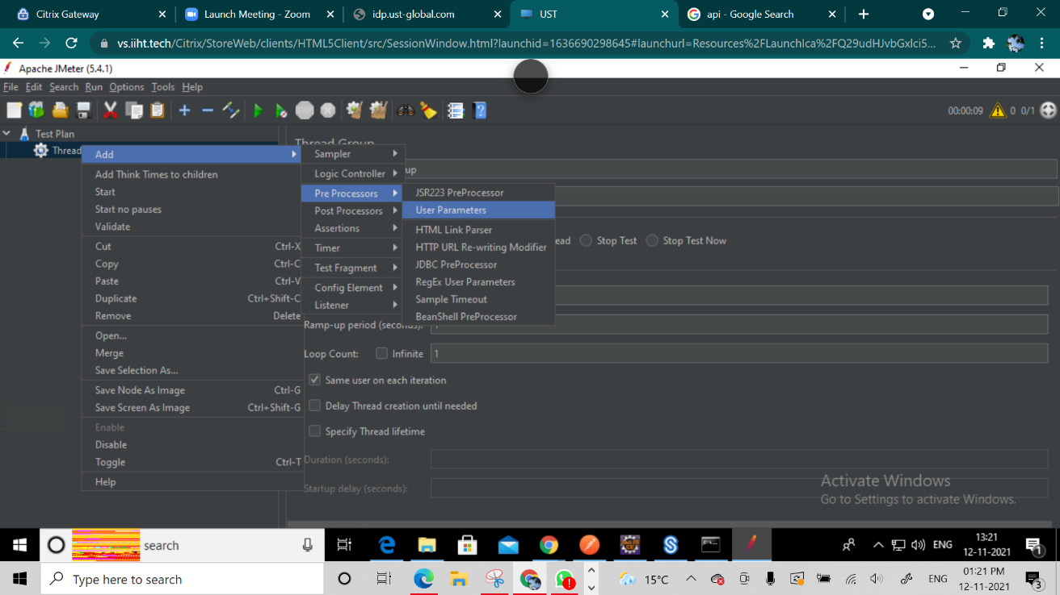

Add parameters using Add Variables

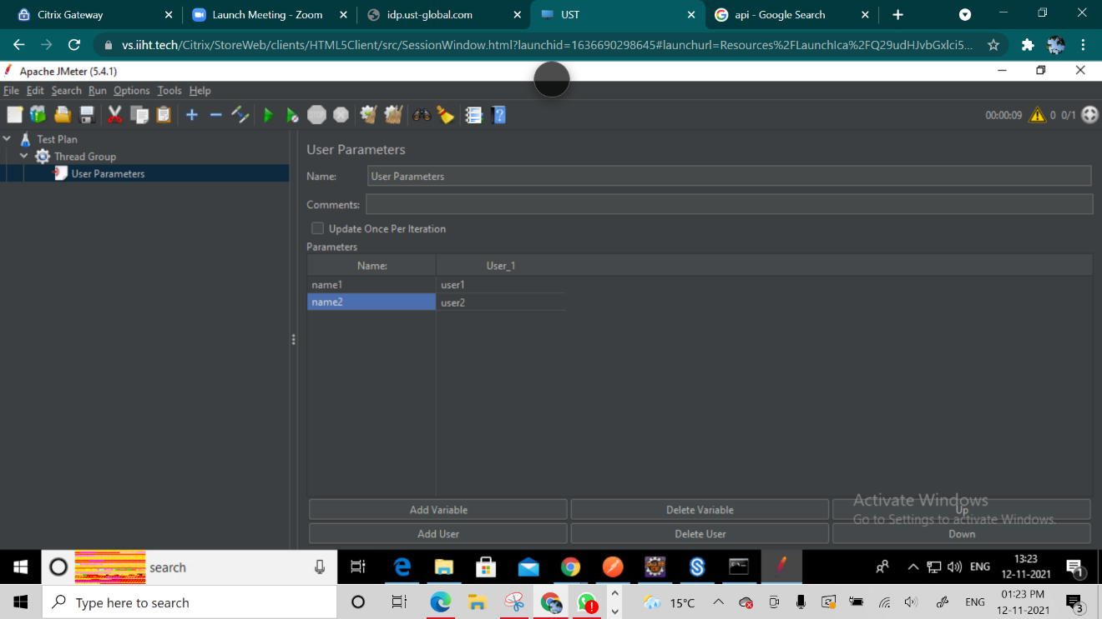

Since it’s is a pre-processor it will get executed before the samples are executed.

Adding an HTTP Request

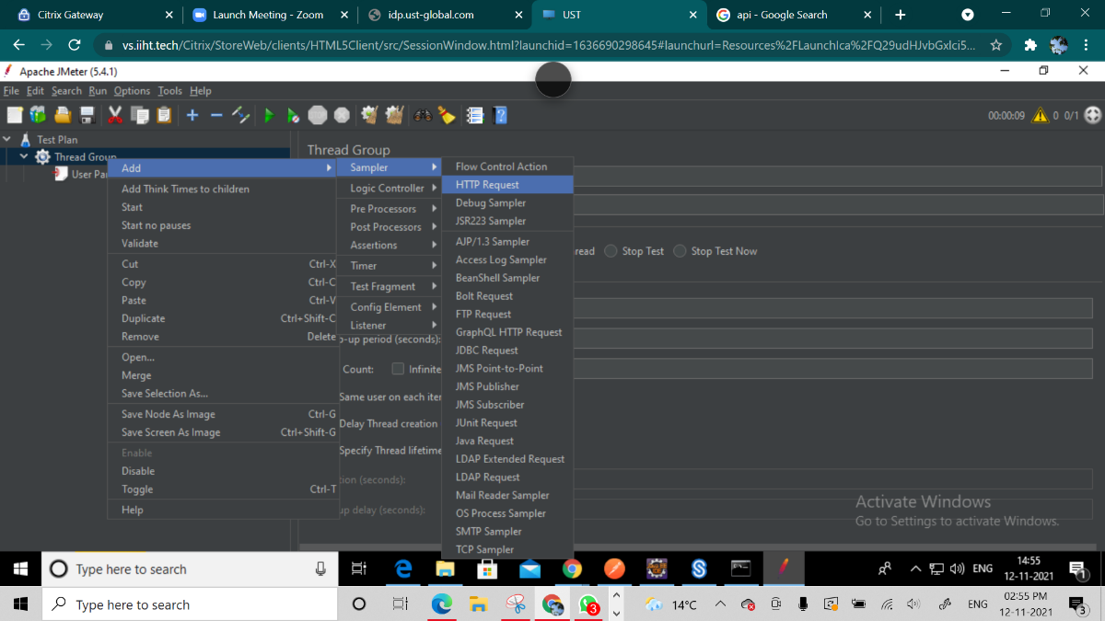

Create two HTTP Requests

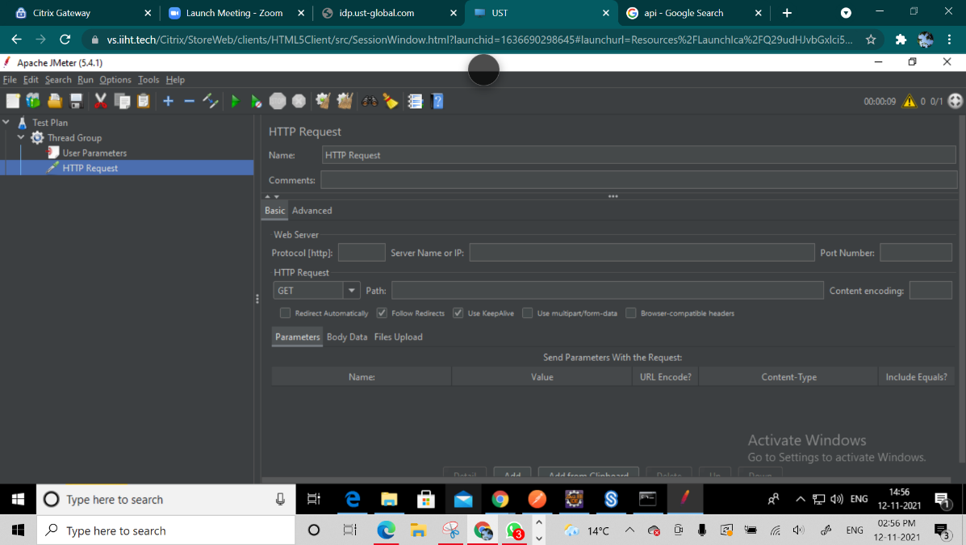

We access the variables in JMeter using $ and Parenthesis{}

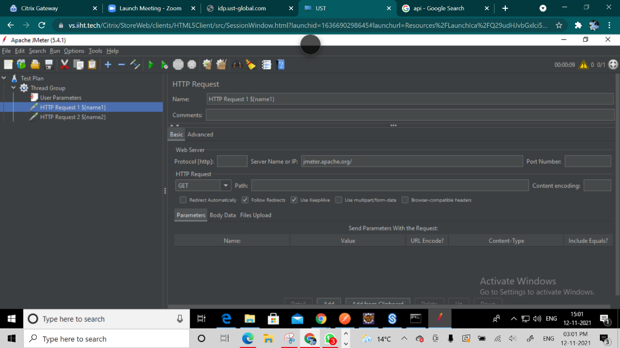

Add a View Results Tree and Run it

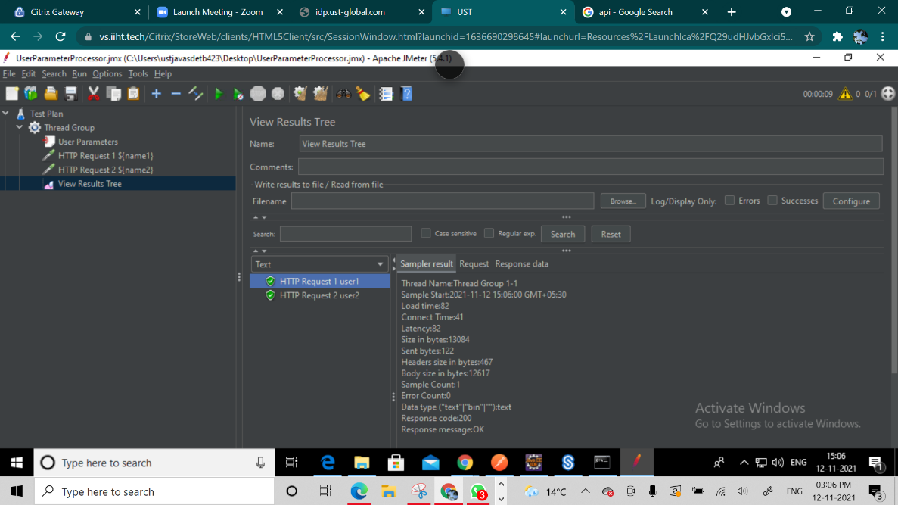

It prints both the Variables and it gets its value from the pre processor.

To open all the urls on page https://jmeter.apache.org/

Create a HTTP Request called Home

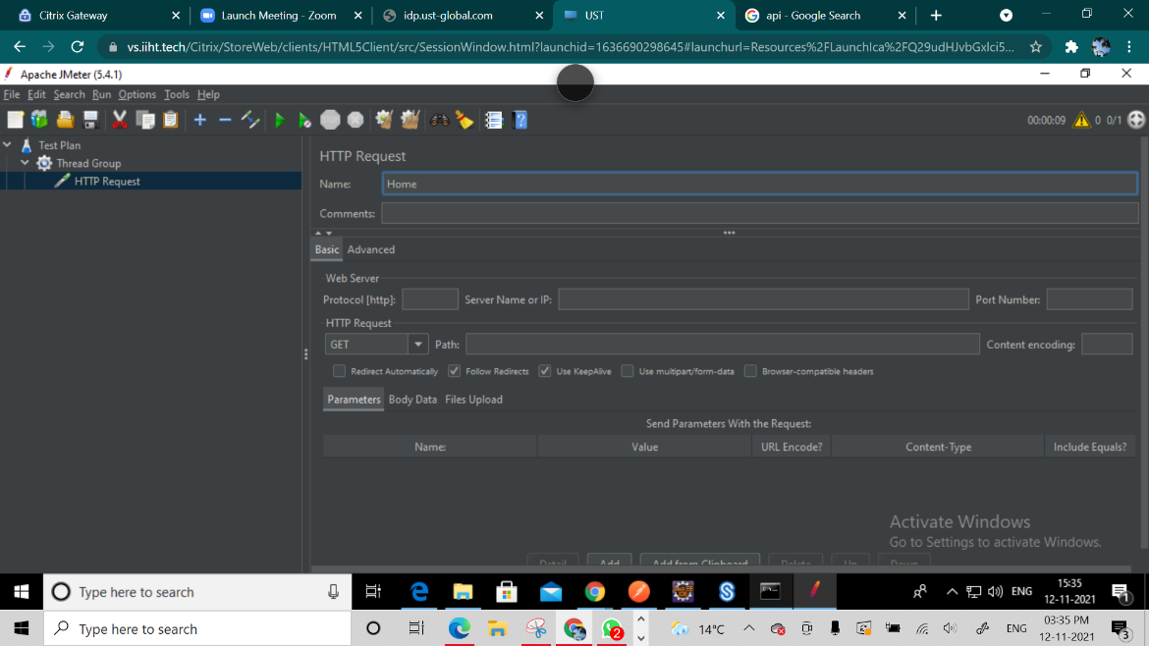

Create another Sampler.

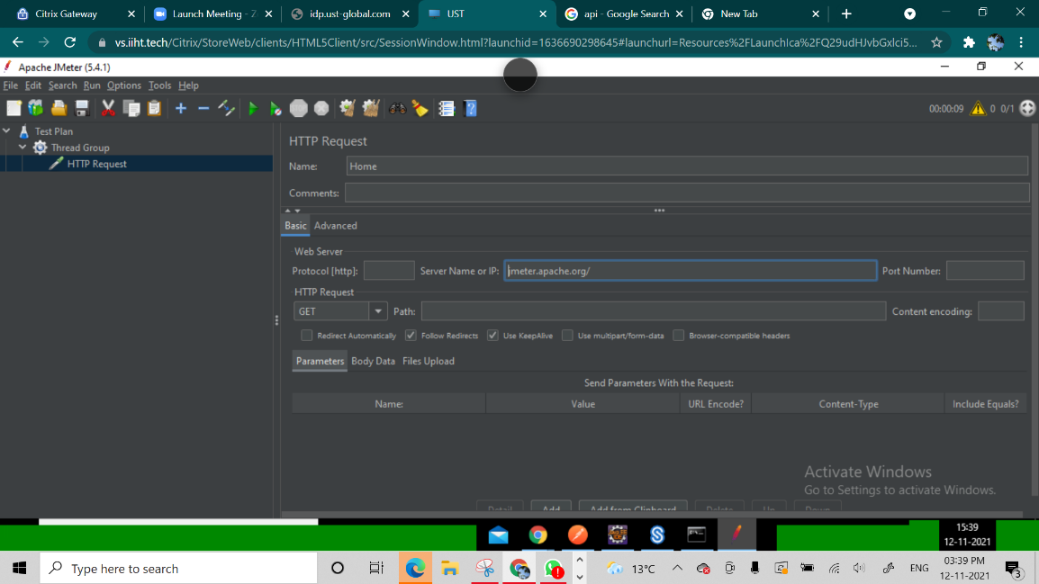

Before the next HTTP Request is executed the Pre-Processor is added

HTTP Request -> Add -> Pre Processor -> HTML Link Parser

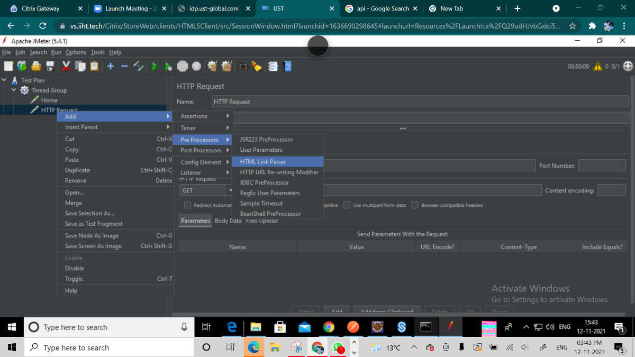

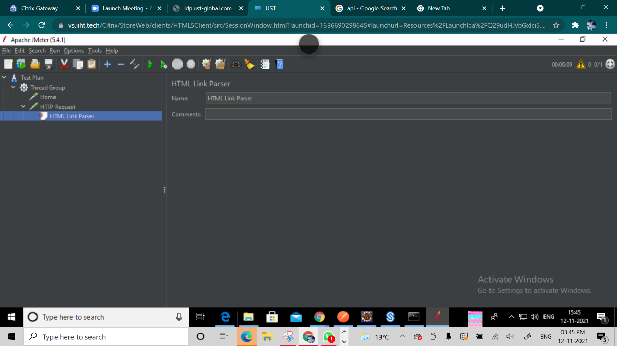

A HTML Link Parser is inserted. The result of Home will be read by HTML Link Parser

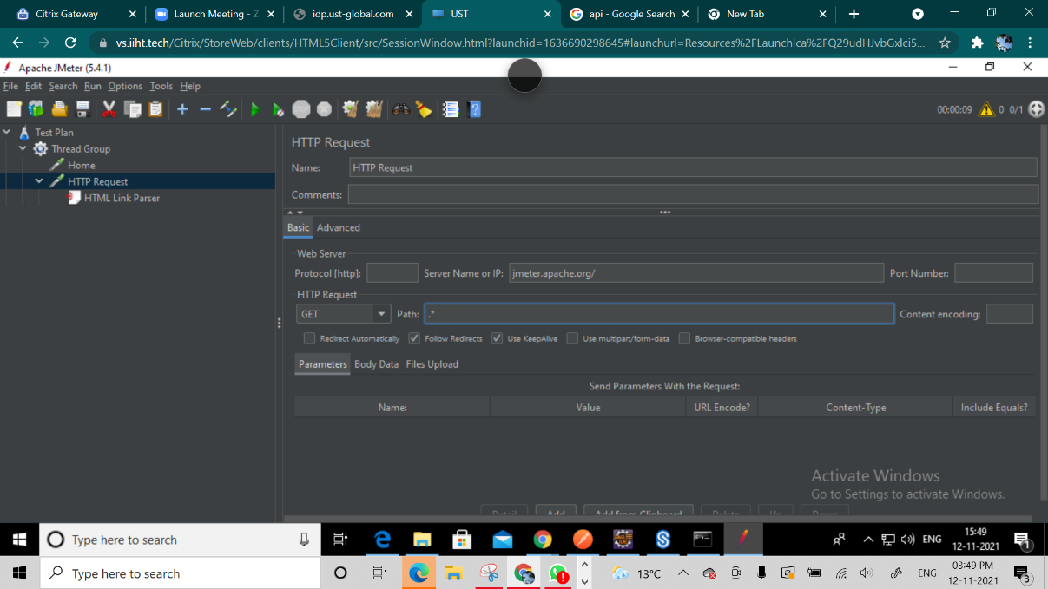

By putting .*

Whatever the data was retrieved by HTML Link Parser from the response of Home that will be executing as response in HTTP Request.

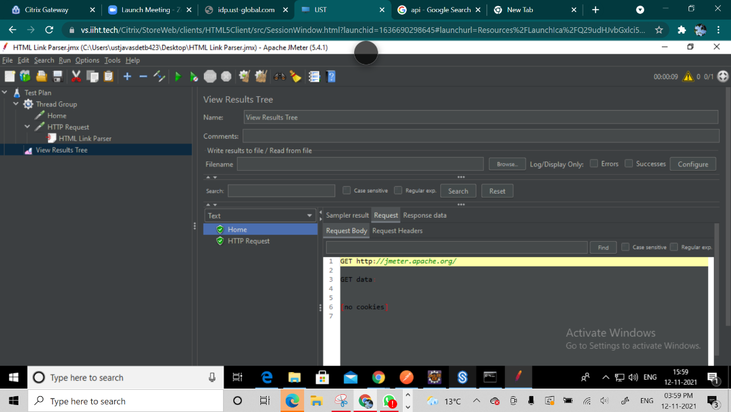

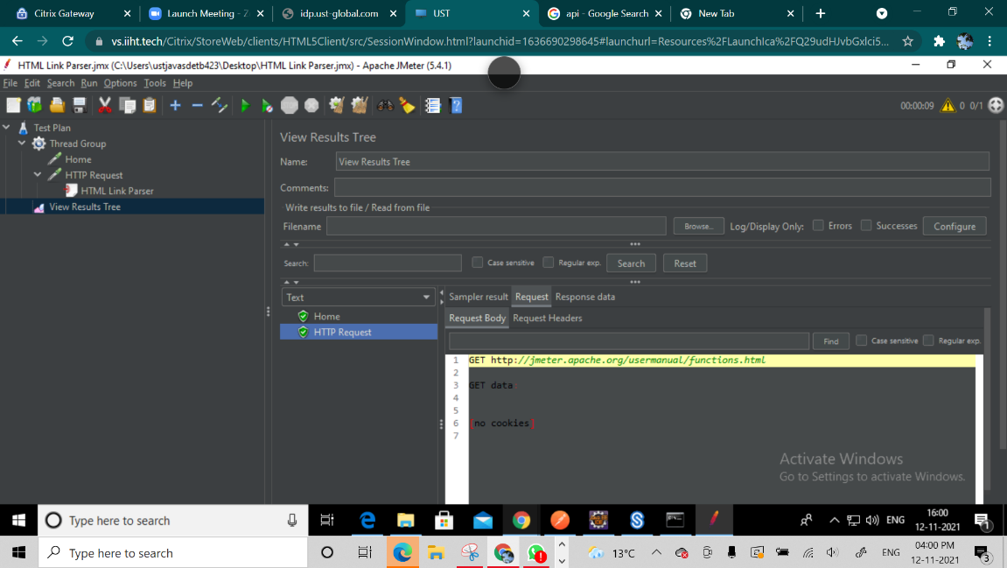

HTML Link Parser captured all the URLs present on the page.It randomly took a URL and opened it.

To view all the URLs we need to add a While Loop

Thread Group -> Add -> Logic Controller -> While Controller

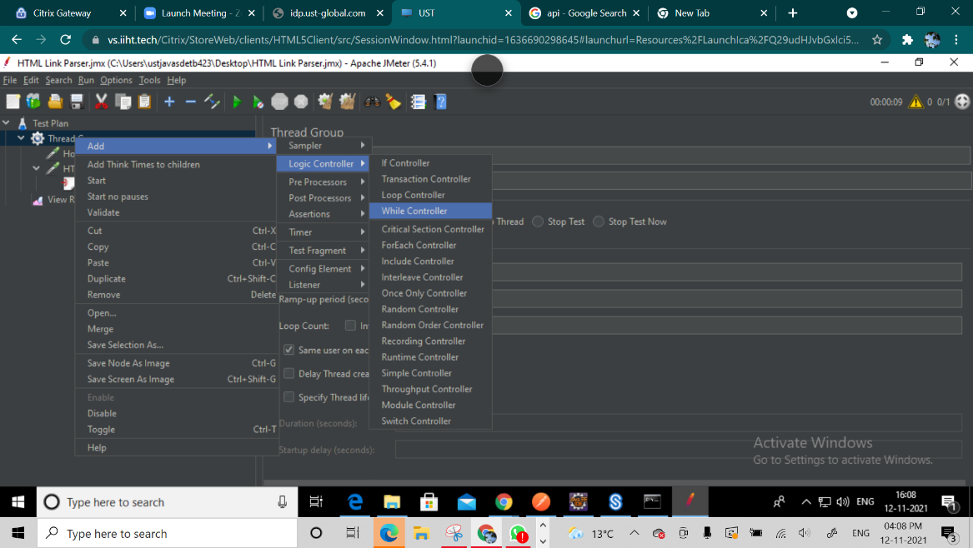

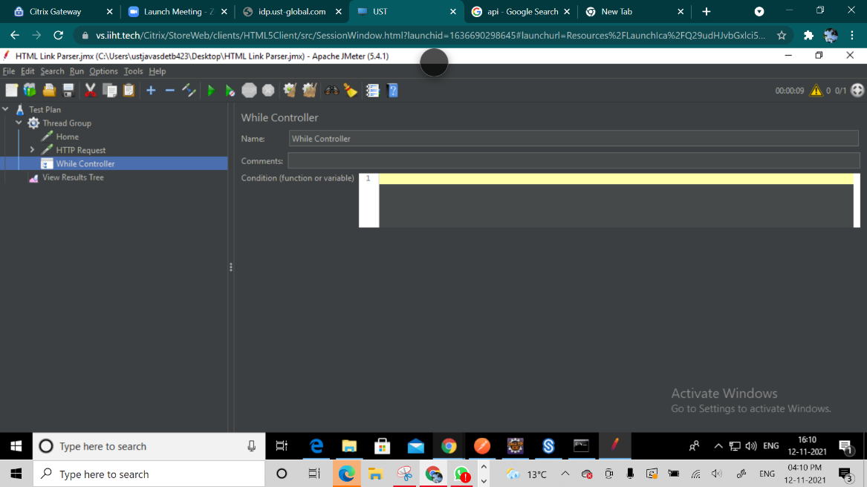

Putting HTTP Request inside the While loop

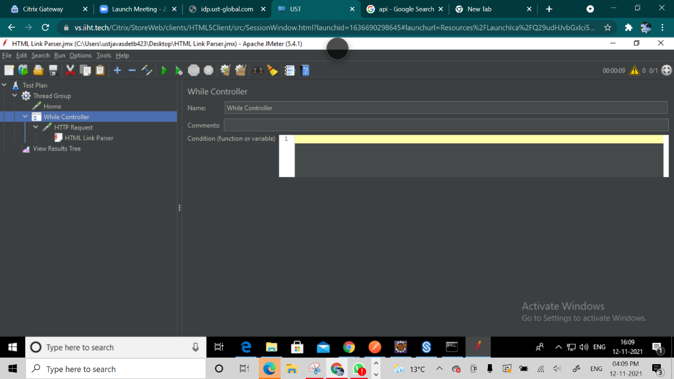

On Running it

